**SANA SANKEERTHANA** 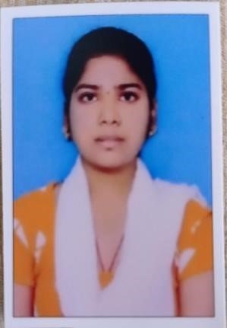

Email:keerthireddy9959@gmail.com

Mobile No.:+91-7995126759

**CAREER OBJECTIVE :**

To pursue a job in challenging environment that encourages creativity and provides exposure to new technology to achieve professional and personal growth along with the organization**.**

**ACADEMIC QUALIFICATION:**

|  |  |  |  |  |
| --- | --- | --- | --- | --- |
| **Course** | **Institution** | **Board/University** | **Year Of Passing** | **Percentage(%)** |
| B.Tech,  Electronics and  Communication  Engineering | Annamacharya  Institute of  Technology and Sciences,  Rajampet. | Jawaharlal  Nehru  Technological  University  Anantapur | Pursuing  (2022-2025) | 8.50  (CGPA)  Upto 3-1 |
| Intermediate with  Maths,Physics, Chemistry. | Medha Junior  College,  Mydhukur. | State Board of  Technical Education  AndraPradesh | 2021 | 89% |
| Secondary Education | Sri  VedhaVyasa high school, Mydhukur. | Board of  Secondary  Education | 2019 | 9.7 (GPA) |

**WORKSHOPS:**

* MATLAB Programming in Industrial Applications.

**TECHNICAL SKILLS**

Programming Languages : Basics of PYTHON,JAVA

**SOFT SKILLS**

* Time Maagement
* Leadership
* Communication Skills

**ACHIEVEMENTS AND CERTIFICATES:**

* Certified in PCB Designing. • Certified in Embedded systems using Arduino.

**PERSONAL DETAILS:**

* Date of Birth : 18-02-2004
* Father’s Name :Sana Sanjeva Mohan Reddy
* Current Address : 1-158 ,Siddareddy Palli ,Chapadu Mandal ,Kadapa dist,516434 • Hobbies :Listening Music,playing Shuttle.
* Nationality :Indian
* Languages Known :English,Telugu
* Any kind of disability :No • Willingness to Relocate :Yes

**DECLARATION**

I here by declare that all the above-mentioned information is true and correct to the best of my knowledge.

**PLACE :**  Signature:

• SiddaReddy Palli 